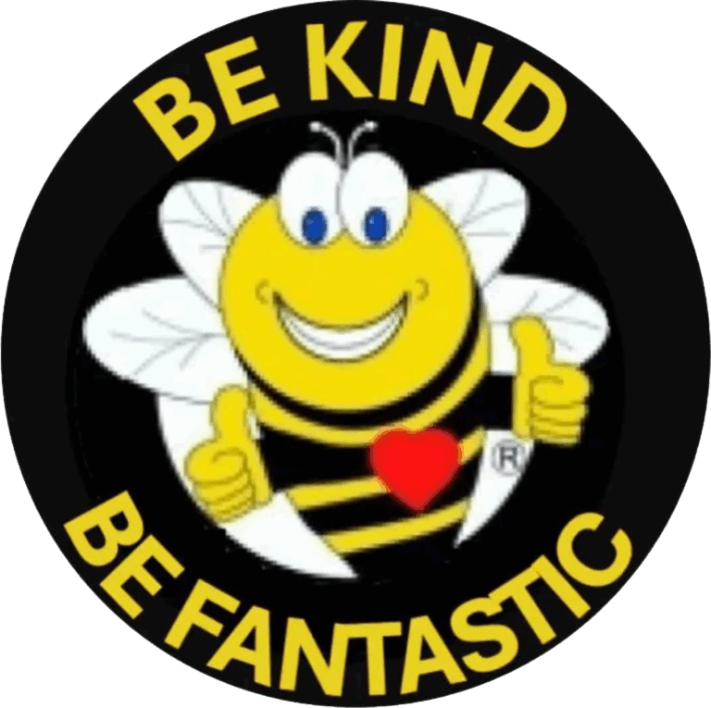
Kindness Class 101
Teacher's Manual
Fostering Kindness in Our Classrooms
Created by: Foundation for W
orld Harmony
T
able of Contents
1
.
1
. Introduction
2
.
. Materials Needed
2
3
.
3
. Opening Circle
.
4
4
. Commitment #1: Be Kind to
Y
ourself
5
.
5
. Commitment #2: Be Kind to
All Others
6
.
6
. Commitment #3: Be Kind to Our Mother Earth
.
7
. Closing: Global Kindness Pledge
7
.
8
8
. Optional Follow-Up
Activities
Introduction
This manual is designed to guide educators in teaching kindness through
interactive and engaging activities.
The goal is to foster a culture of kindness
within the classroom and beyond, empowering students to make a positive
impact on their communities and the world.
Materials Needed
Whiteboard or chalkboard
Paper and pens/pencils
Kindness journals (optional)
Printed copies of the Global Kindness Pledge
Markers or colored pencils (for optional activities)
Opening Circle
(5
)
minutes
T
eacher says:
"W
elcome to Kindness Class.
T
oday we're going to talk about how kindness can
change the world — starting with you."
Ask the class:
"What does kindness mean to you?"
"Who's someone kind you admire, and why?"
)
Allow a few students to share.
(
Commitment #1: Be Kind to YOURSELF

(15 minutes)

T
eacher says:
"The first and most important commitment is: Be kind to yourself. If we don't
love and care for ourselves, it's hard to share true kindness with others."
Discussion Prompts:
"What are some kind things you can say to yourself when you're feeling
down?"
"Can you think of a time you forgave yourself or gave yourself a break?"
"Why is being kind to yourself important before helping others?"
Activity:
Students write 3 kind af
firmations to themselves (e.g., "I am enough." "I can
grow
." "I matter
.")
Invite volunteers to share one af
firmation aloud.
Commitment #2: Be Kind to
All Others

(15 minutes)

T
eacher says:
"The second commitment is: Be kind to all others. Kindness is not just for
friends or family — it's for everyone, even people we don't understand."
Discussion Prompts:
"What does it look like to be kind to someone who's dif
ferent from you?"
"Have you ever been the person who needed kindness? What helped?"
"How do small acts of kindness ripple out into the world?"
Activity:
In pairs or small groups, students come up with one act of kindness they can
do this week — at home, in school, or online.
Share with the class.
Commitment #3: Be Kind to Our Mother Earth

(10 minutes)

T
eacher says:
"The third commitment is: Be kind to our Mother Earth. She gives us everything
— air
, water
, food, beauty
. Being kind to the Earth is being kind to ourselves
and each other
."
Discussion Prompts:
"What are some ways we hurt the Earth without meaning to?"
"What are 3 simple things we can do to take better care of her?"
"How does kindness to the Earth af
fect future generations?"
Activity:
Brainstorm a "Class Kindness-to-Earth Plan" — 1 thing the class agrees to
do as a team (e.g., clean up the schoolyard, recycle more, plant something).
W
rite it on the board.
Closing: Global Kindness Pledge
minutes
)
(5
T
eacher says:
"Let's close by making a promise — to ourselves, to others, and to the Earth.
This is the Global Kindness Pledge. Let's stand, put our right hands over our
hearts, and say it together
."
🕊
Global Kindness Pledge
I pledge to be kind and love myself
I pledge to be kind to, and strive to love all others
I pledge to be kind to, love, and respect our Mother Earth,
W
e are Fantastic
(
Have them point-to-point another
)
Y
ou are fantastic
I am fantastic
Optional Follow-Up
Activities:
Distribute "Kindness Journals" for students to track how they practiced the
Three Commitments during the week.
Invite students to bring in stories, poems, or art inspired by kindness to
share in the next class.
Organize a school-wide "Kindness Challenge" where students complete acts
of kindness and share them with the class.
Plan a field trip to a local charity or community organization to learn about
how they spread kindness.

